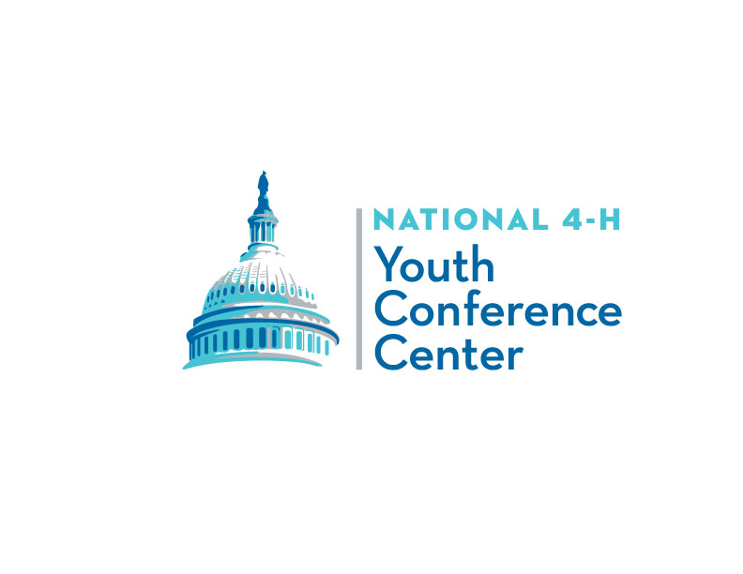
Media and Information Release

Participant Name: ___________________________________________________________________________

I give to the National 4-H Council, National 4-H Youth Conference Center, its nominees, agents, and assigns, unlimited permissions to copyright and use, publish, and republish for purposes of advertising, public relations, trade, or any other lawful use, information about me and reproductions of my likeness (photographic or otherwise), my voice, and any related written text, whether or not related to any affiliation with 4-H, with or without my name. I hereby waive any right that I (and Minor) may have to inspect or approve the copy and/or finished product or products that may be used in connection therewith or the use to which it may be applied.

Participant’s Signature: ________________________________________ Date: _________________________

Consent of parent or legal guardian if above individual is a minor:

I consent and agree, individually and, as parent or legal guardian of the minor named above, to the foregoing terms and provisions. I hereby warrant that I am of full age and have every right to contract for the minor in the above regard. I state further that I have read the above information release and that I am fully familiar with the contents.

Name: ______________________________ Relationship: ______________________

Parent/Guardian’s Signature: ______________________ Date: _________________

Code of Conduct

Participant Name: ___________________________________________________________________________

I hereby agree to attend Citizenship Washington Focus, participate fully in all sessions and abide by the established rules.

Specific rules include, but may not necessarily be limited to the following:

- Quiet is to be observed in sleeping room areas after specified times each night. All participants are to be in their own rooms at such time. During other hours, boys and girls may not be in the same sleeping room.
- The use of alcohol, tobacco, or illegal drugs is not permitted.
- All participants shall show respect for the property and facilities used during this event and assume financial responsibility for any damages they cause.
- All participants are responsible for attending all scheduled activities during the event. Any unauthorized absence is not permitted.
- All participants should have respect and courtesy for programs and speakers in progress by remaining for the entire program and show courtesy when taking flash photos during speeches and entertainment.

If I break this agreement or my conduct is not satisfactory to the conference center staff, I understand that I can be sent home early and will be responsible for paying any costs incurred for this transportation. I also may be asked to return all funds expended on my behalf for my involvement in this event. I understand that I may not be eligible to participate in future activities of this sort, either at the national, state, or local level.

Participant’s Signature: ________________________________________________ Date: _________________

Parent/Guardian’s Signature: ___________________________________________ Date: _________________
Page 2

